Understanding the Standard Error of the Mean (SEM)
The standard error of the mean (SEM) tells us how precisely a specific sample mean estimates the true population mean.
Imagine that we want to know the average systolic blood pressure of all patients taking a medication. Measuring every patient is impossible, so we measure a sample of patients in a study and calculate a mean value.
If we repeatedly performed the study and selected new study samples each time, each study sample would probably have a slightly different mean. If we plotted each individual study’s BP mean value, they would cluster around the true (but unknown) population mean:
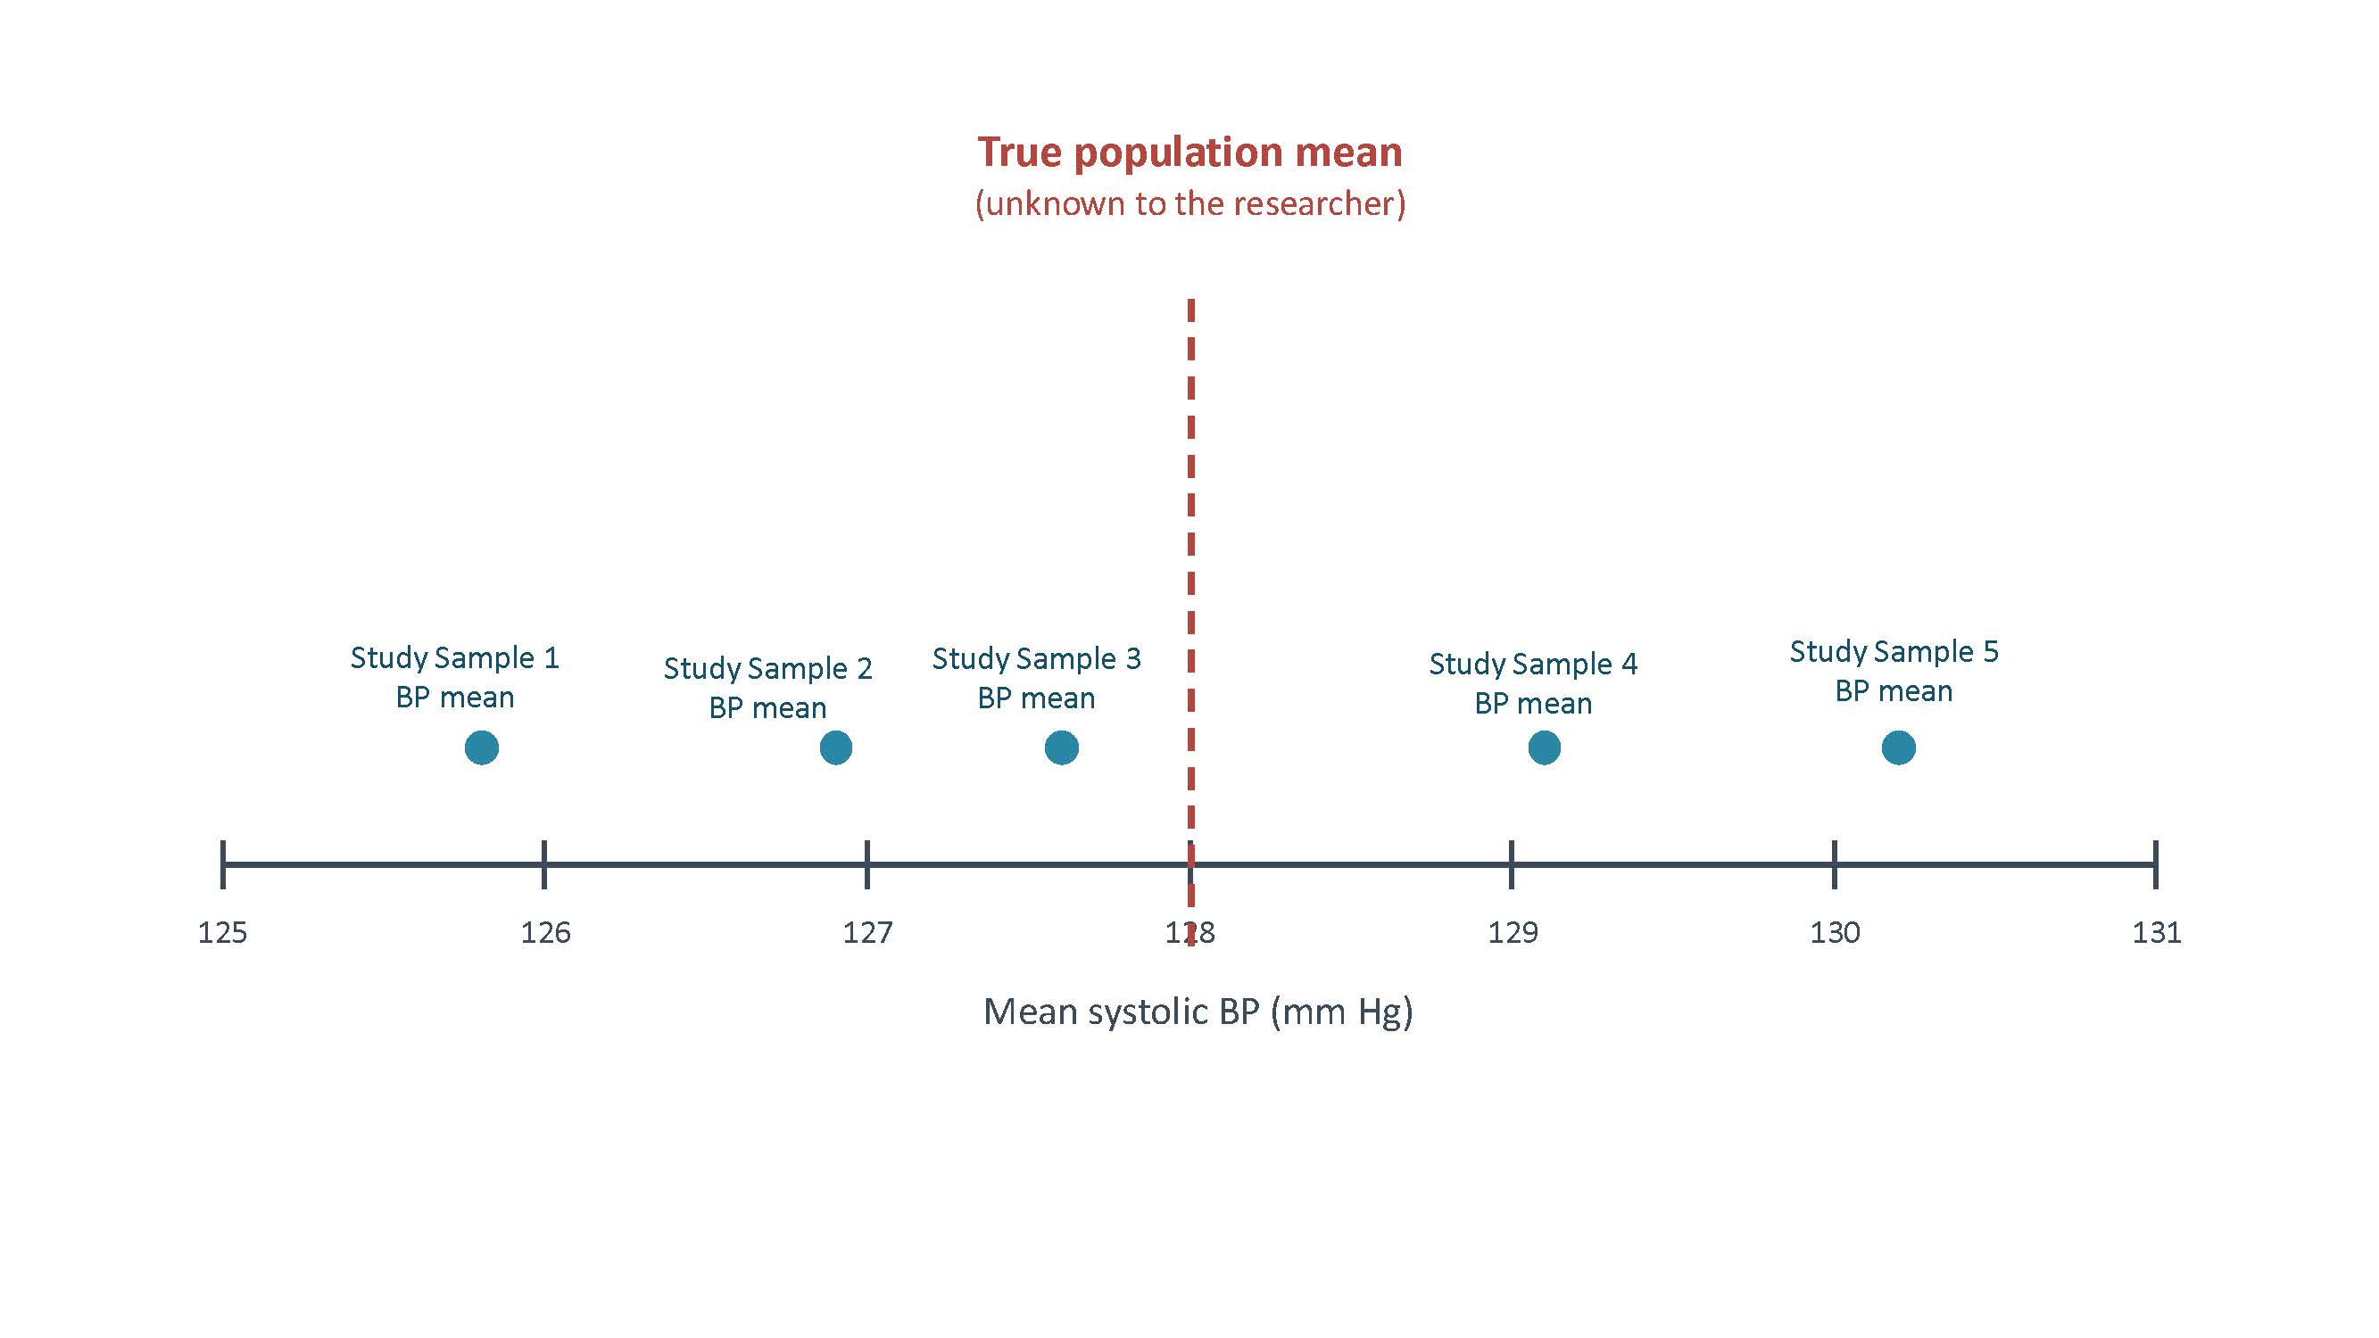

What the SEM describes: the expected amount of variation among individual study sample means (this is a rather theoretical value) —and therefore, it is an estimate of how precise each sample mean is.

A small SEM means the individual sample means would cluster closely together, giving us a more precise estimate of the overall population mean. A large SEM means the individual sample means would be more spread out, giving us a less precise estimate of the unknown population mean value.
SEM = SD ÷ √n
Because SEM becomes smaller as the sample size increases, a larger study sample mean generally estimates the unknown population mean more precisely. Why? A larger study sample usually produces a smaller SEM because a mean based on more patients will more closely estimate the overall population. But, increasing the sample size does not necessarily make the individual patients less variable.

The most important point:

SD describes variation among individual patients in the study. SEM describes the precision of an overall study sample mean (rather theoretical)

